DISTRICT INSTITUTE OF EDUCATION AND TRAINING
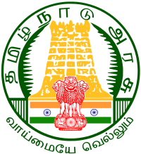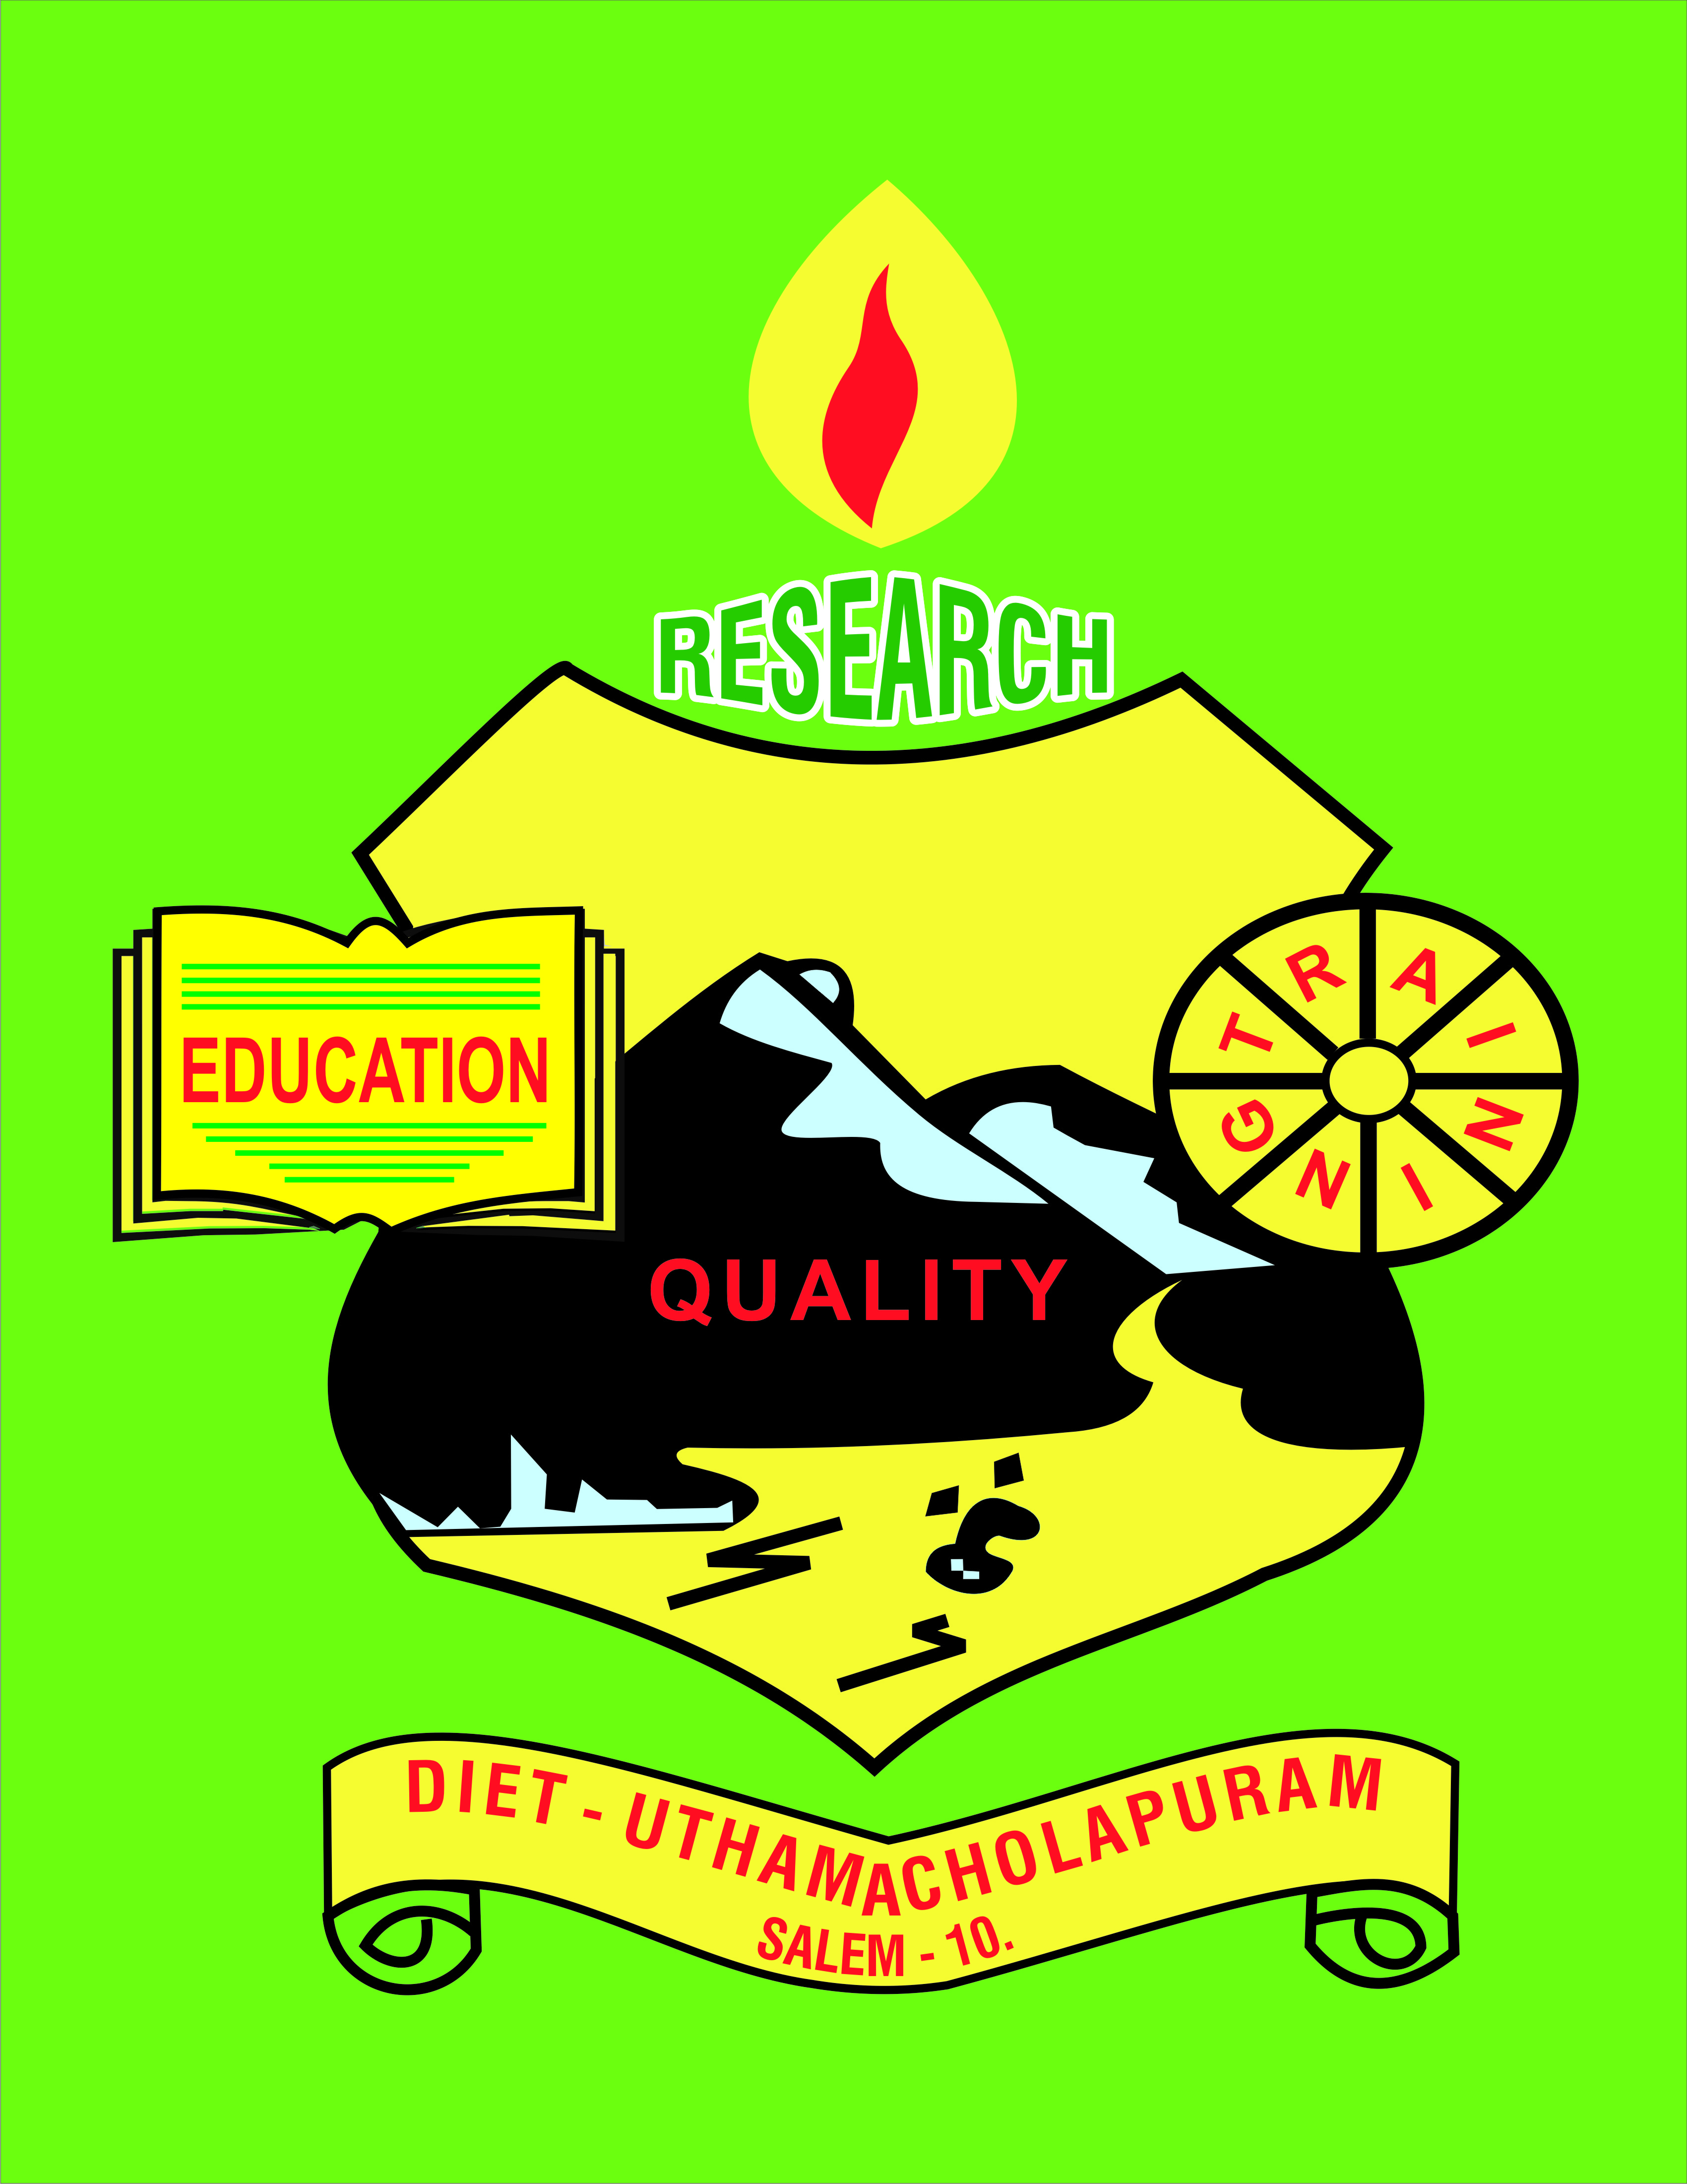

Uthamacholapuram, Salem-636010
November– 2022 PREPARED BY: Publication Division Vol.No.5 S.No.11

SPECTRUM
ECHO OF DIET SALEM
EE
Ece

Awareness of Educational Rese

Nature : Scientific Facts and Inventions
“Learn from yesterday, live for today, hope for tomorrow. The important thing is not to stop questioning.” - Albert Einstein
Curiosity is a basic characteristic of scientists in many fields. The ability to observe and form hypotheses to verify or refute is a foundation of the scientific method. Understanding of the natural world inspired many scientists to discover and invent. Today, our scientists are continuing in the footsteps of famous scientists. By seeking answers to complex questions in Nature, these modern-day pioneers are providing fundamental knowledge to advance the health of animals, people, and our planet.
You know this is strange but true that there are more trees on Earth than the stars in the Milky Way. Scientists estimate there are between 3 Trillion trees on Earth. Trees live a long time like the stars and are essential for life also.
People are generally scared of Sharks but do you know that Cows kill more people than sharks? According to the reports, Sharks kill about five people per year while cows kill about 22 people yearly. Hard to believe, but it's true. Humans are deadlier to sharks than they are to humans. Global shark populations have decreased by 70% due to the destructive fishing methods used by all major fishing nations, which result in the annual slaughter of around 100 million sharks.
Pineapple plants produce flowers 12-15 months after planting, and the fruits become ready 15-18 months afterward. Next time when you eat pineapple, don't waste it!
Some Interesting facts about Nature :
- A cockroach can live for up to one week without its head.
- Water at the same time can exist in three states
- Sound travels faster in water up to four times than in air.
- Bananas are radioactive.
- Humans use less than 1% of available water.
- Cats have over 100 vocal sounds, whereas dogs only have about ten.
- Fleas can jump 130 times their height.
- Snakes are true carnivores because they only eat other animals and do not eat plants.
Inventions Details LED Bulbs The LED bulbs reflect more light; the idea has been taken from the Firefly because the Firefly has such a type of body structure that emits light. A group of researchers from several countries looked into this and discovered that the Firefly, a kind of lantern, had a jagged exoskeleton with protruding scales. This prevents reflection and lets most of the light out, which was not the case with a regular bulb.
Aquatic Vehicles As we know, Sharks are the most efficient swimmers. Their skin has tiny grooves that help vessels linked to the surface move more slowly. This sharkskin film is used on conventional objects like coatings for ship's hulls, submarines, aircraft, and even swimwear for humans. Sonar French physicist Paul Langevin 1915 invented a system called SONAR to utilize sound waves and their echoes to locate objects underwater. Bats and dolphins are already using this technique to emit sounds and hear echoes for detecting and locating objects around them.
Velcro is a well-known name in today's time. It was invented by Swiss engineer George de Mestral when he saw the burrs from the burdock plant latched onto his pants. He found that tiny seed hooks allowed them to stick on his pants. However, it took Mestral over a decade of experimentation to replicate it perfectly into what he called the "zipper less zipper," also known as Velcro.
Shinkansen bullet train EijiNakatsu, an Engineer at the Japanese rail company, made the bullet trains and was also an avid bird-watcher. When he observed that he could apply the structure of the Kingfisher's beak to the bullet trains, he did it and realized that it increased energy efficiency, permitted faster speeds, and emitted less sound. Earlier Bullet trains were initially designed to emit a loud thunderous noise when exiting tunnels.
Scotch Tape Richard Gurley Drew invented the Scotch tape in 1922. At that time, he used to deliver samples of sandpaper to his near way automotive shops, where he often heard some workers complaining about the tape residue used during car painting. In his two years of research, Drew experimented with various adhesives and came up with one product that wouldn't leave any residue once it was peeled off. This leads the invention of Scotch Tape.
Suction cups Suction cups have been designed using principles of vacuum and pressure because these objects can be used to stick things on the walls. Suction cups are a tool that is used to attach or tightly grip flat surfaces.
Butterflies & Solar Power The black wings of the rose butterfly are two times more efficient at harvesting light, which inspired a new type of solar cell. The Butterfly wings are elegant feats of Nature but can also have unique solar properties. The rose butterfly has tiny cells on its intricate and delicate wings that can collect light at any angle.
Neelam Pandey : The author is an active Science Communicator and a Junior Project Associate at Vigyan Prasar. Email: neeruc179@gmail.com
Dr M .Selvam-Principal
- Discussed on ‘Best practices on Ennum Ezhuthum’ for making video with Mr. Sureh, SGT, PUMS, Mattukaranputhur on 01.11.2022.
- Acted as a Resource Person in Tamil Nadu Leadership Programme on 14.11.2022 at Pillar Hall, Madurai and CEO’s Training from 05.11.2022 to 06.11.2022.
- Coordination meeting with Mr.Ramnath, Azim Premji University, Bengaluru and Mr.Santhosh, DEO (Elementary) Salem.
- Acted as a Resource Person for DEO’s (Elementary) Training at Pillar Hall, Madurai from 11.11.2022 to 12.11.2022 and DEO’s (Secondary) on 20.11.2022.
- Inaugurated Voluntary Initiative on “learning Outcomes” Training to Middle School to HSS HM’s at Padmavani College, Salem from 14.11.2022 to 19.112022.
- Inaugurated “Naan Mudalvan” training centre at Padmavani College and Salem Engineering College, Mettupatty on 15.11.2022.
- Visited GHSS, Thandavarayapuram on 15.11.2022.
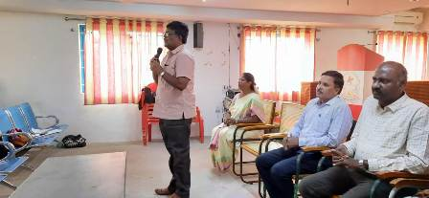
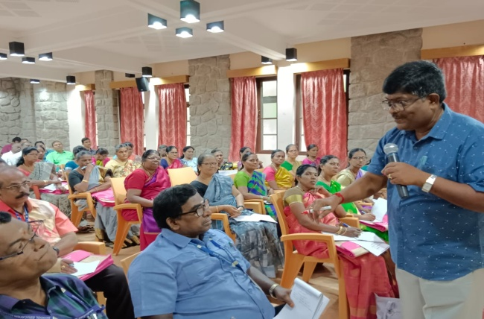
- Attended the Google Meet on “District Facilitator” training for CRC meeting, which was organized by SCERT-Chennai on 22.11.2022.

- Inaugurated District Facilitator training for CRC on Ennum Ezhuthum on 24.11.2022 and Phonetics on 25.11.2022 at CSI-TTI, Hasthampatty, Salem.
- Visited PUMS, Pakalpatti on 28.11.2022, PUPS, T.Konganapady and PUMS, Nachampatty on 29.11.2022.
PRE-SERVICE TEACHER EDUCATION: (PSTE)
Dr P.Govinda Prakash - Senoir Lecturer
- 02.11.2022-Attended GDP meeting Salem Collectorate office, Salem.
- 10.11.2022-Prepared Teachers name list for Archeology Training programme at CEO office at Salem.
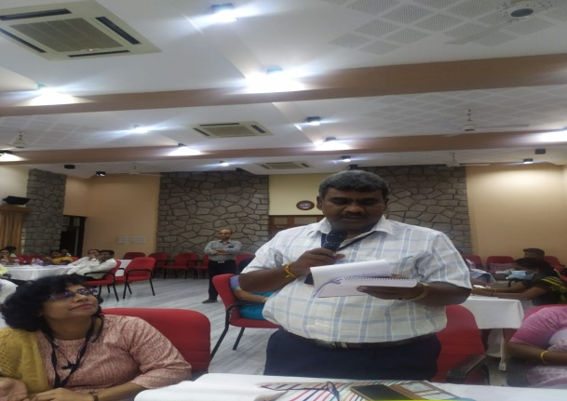
- 11.11.2022- Prepared Teachers name list for Archeology Training programme at CEO office at Salem.13.10.2022 to18.10.2022- Participated Capacity Building Training at Pillar Hall, Madurai District.
- 23.11.2022 to 25.11.2022- Organized and Co-ordinated District facilitator Training for 1ststd to 3rd std and 4thstd to 5th std school teachers at CSI TTI, Hasthamapatti, Salem.
Mrs. S. SELVI- Lecturer
- 01.11.22 to 04.11.22-Attended Capacity Building training Programme for DIET faculty members at Pillar Hall, Madurai by Azim Premji University faculty members.
- 07.11.22-Meeting Attended on the Azim Premji University faculty member visit at DIET.
- 08.11.22-English Module correction work was done for SSA/RMSA.
- 11.11.22-Visited Phonetics and Spoken English training Programme at CRC, Magudachavadi GHSS, Vaikuntham, Salem.
- 14.11.22 to 18.11.22-Acted as a resource person and Learning Outcome training was given to All School HM’s (Elementary/Middle/High/Higher) at Padmavani College, Omalur, Salem.
- 28.11.22-Newsletters correction work was carried out at DIET.

Mr. R.Ravi-Lecturer
01.11.2022 | Visited School for Ennum Ezhuthum at PUMS, Mattukaranputhur, Kadayampatti Block.
03.11.2022 to 05.11.2022 | Attended “Naan Mudalvan’’ Training at ACL, Chennai.
07.11.2022 | Visited ITK centre at Thalavaipatty, Kombai.
08.11.2022 | Visited School for Ennum Ezhuthum Classroom activities at PUMS, Kannapadi, Kadayampatti Block.
09.11.2022 | Visited “Naan Mudalvan college, Salem.
10.11.2022 | Visited School for Ennum Ezhuthum Classroom activities at PUES, Naivakadu, Kadayampatti Block.
14.11.2022 to  16.11.2022 | Acted as a Resource Person for “Naan Mudalvan” training programme for P.G. Teachers at Padmavani College, Salem.
17.11.2022 | Visited School for Ennum Ezhuthum Classroom activites at PUMS, Guruvareddiyur, Kadayampatty Block.
22.11.2022 | Learning Outcome preparation work was done for 6th std Social Science subject.
23.11.2022 | Visited School for Ennum Ezhuthum Classroom activities at PUES, Rasiputhan KattuValavu, Kadayampatty Block.
24.11.2022 | Visited ITK centre Kadayampatty Block.
25.11.2022 | Visited School for Ennum Ezhuthum Classroom activities at PUES, Gundakal.
29.11.2022 | Attended “Kalai Thiruvizha” at GHSS, Nadupatti and Visited ITK center at Thalavaipatti, Kadayampatty Block.

In-Service, Field Intraction, Innavation And Coordination: (IFIC)
Dr K.Ramesh Kumar - Lecturer
- 01.11.2022 - Visited PUMS Mattukaran Pudur of Kadiyampatti block with DIET Principal and gave onsite support to enhance Ennum Ezhuthum activities.
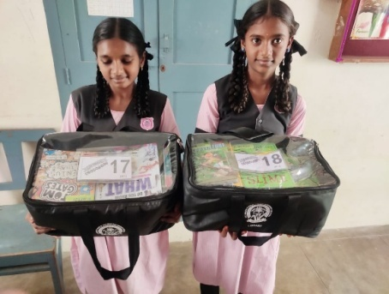
- 04.11.2022 & 05.11.2022 -Attended State level KRP training on “Naan Mudalvan” at Anna Century Library, Kotturpuram, Chennai.
- 9.11.2022 - Attended and Presented about the work carried out before APU faculty member Mr.Ramnath at DIET, Salem.
- 10.11.2022 - Visited St.Mary’s Hr. Sec. School, Arisipaliyam along with DIET Principal and reviewed Classroom Library Project

11.11.2022
Visited St Nicolous Aided Middle School, Omalur along with APU Faculty member Mr. Ramnath, DIET Principal, DEO Salem & DEO Dharmapuri. Observed School Quiz programme and Online Radio project of the school.
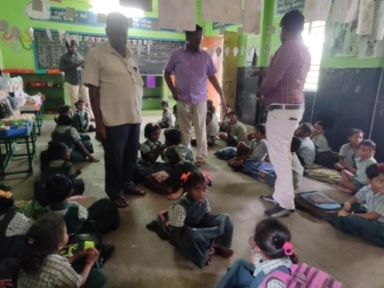
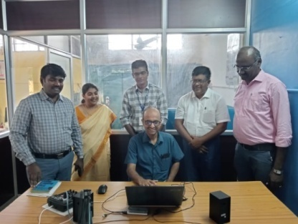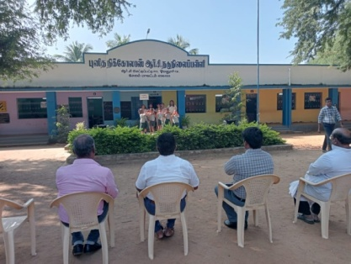
14.11.2022 & 15.11.2022 - Coordinated and Organized ‘Naan Mudalvan’ training at district level in Salem Engineering College Mettupatti. 110 Post Graduate teachers were participated in the training programme.
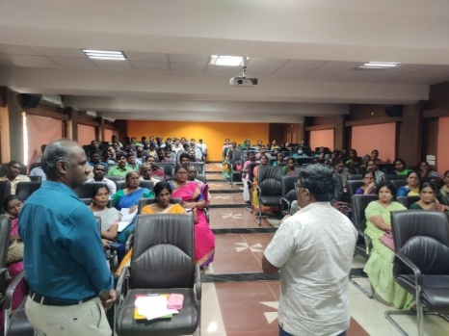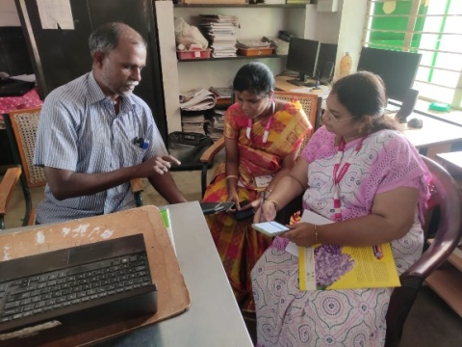
17.11.2022
Visited PUMS Krishnamputhur along with DIET Principal and Head of the Departments of Tamil and Statistics of Padmavani College of Arts and Science. Discussions were made on training the students on Model making and Bird watching.
24.11.2022
Attended INDO - SOUTH KOREA - THAILAND Conference I-NEEBA 2022, organised by VMKV Arts and Science College, Salem and chaired a Session.
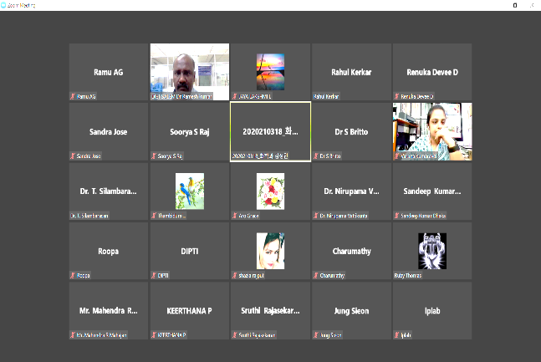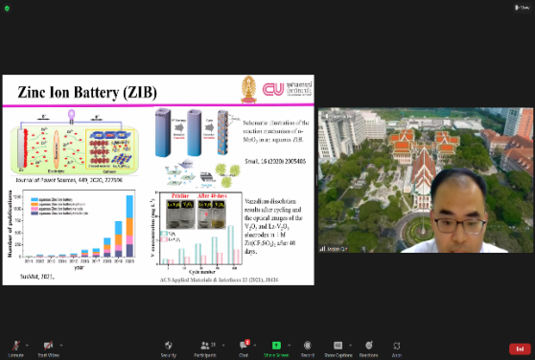
25.11.2022
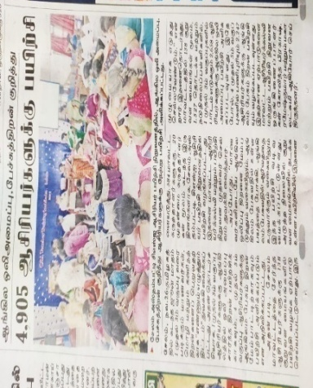
Coordinated District CRC Facilitators training for Spoken English and Ennum Ezhuthum training at CSI TTI, Hasthampatti.
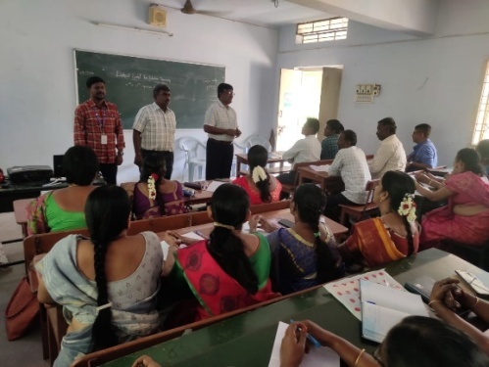

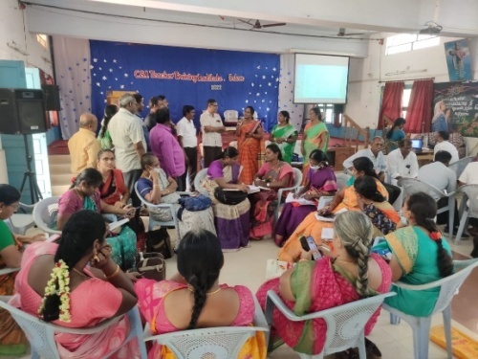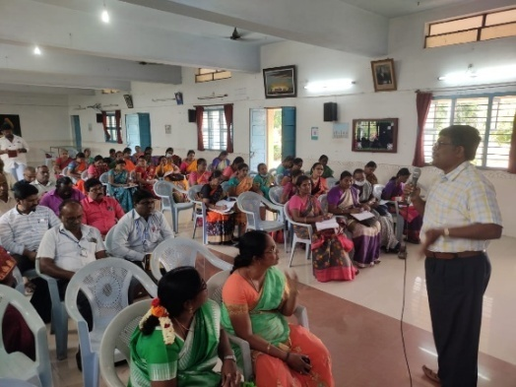
28.11.2022
Visited PUES Palbaki of Omalur block along with DIET Principal.Reviewed Ennum Ezhuthum activities in the School.
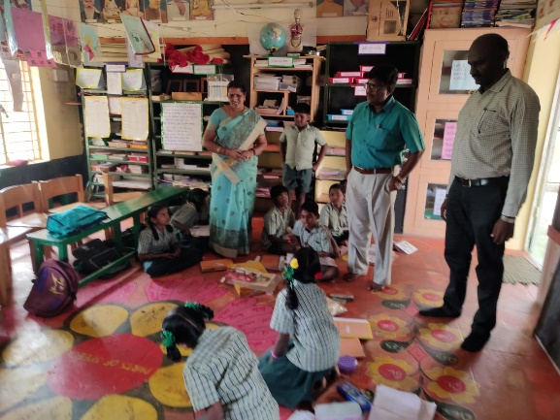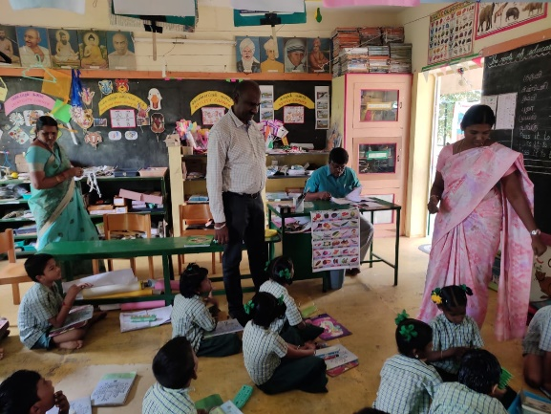
Mrs. M.Mahalakshmi-Lecturer
- 9.11.2022 to 11.11.2022 -Attended Workshop and Training programme on Module Preparation for LKG and UKG at SCERT-Chennai.
- 24.11.2022 to 25.11.2022-Organized and Coordinated EnnumEzhuthum and Spoken English Training Programme at CSI-TTI,Hasthampatti,Salem.
EDUCATIONAL TECHNOLOGY:(ET)
Dr G.Dhanammal-Senior Lecturer
- 07.11.2022-Attended DIET activities review meeting in presence of AzimPremji University, Bengaluru faculty member held at DIET ,Salem.
- 10.11.2022 to 11.11.2022-Prepared Learning Outcome content development work for 9th and 10thstd Social Science Subject.
- 14.11.2022 to 18.11.2022-Participated in the Academic Personnel Essential Theme Training Programme at Pillar Hall,Madurai.
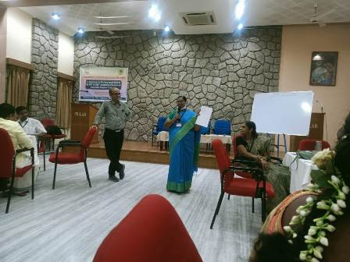
- 21.11.2022&22.11.2022-Prepared the Relationship of Life and Content for 6thstd-Term-III Social Science Subject.
- 24.11.2022&25.11.2022-Attended CRC,Spoken English Training for 1-5thstd teachers at CSI-TTI,Hasthampatti,Salem.
- 28.11.2022&29.11.2022-Prepared the Relationship of Life and Content for 6thstd-Term-III Social Science Subject.
Mrs.M.Jayamani-Lecturer
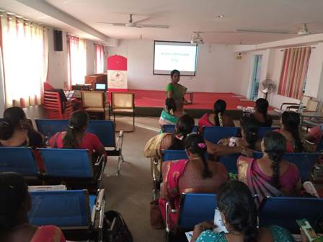
- 01.11.2022- Newsletter consolidation work was seen.
- 07.11.2022- Late Bloomberg Module correction work was seen.
- 10.11.2022 to 12.11.2022:-Learning Outcome preparation work was seen.
- 14.11.2022 to 18.11.2022-Acted as Resource Person for Learning Outcome Training for Higher Secondary School HM’s, High School HM’s and Middle school HM’s at Padmavani College, Salem.
- 21.11.2022: Digital Content Preparation work was seen.
CURRICULUM , MATERIAL DEVELOPMENT & EVALUATION:(CMDE)
Dr R.Nagalakshmi-Senior Lecturer
- Attended Essentials training on Designing and facilitation skill at Madurai ,Pillar Rock from31-10-2022 to 04-11-2022.
- Co-ordination meeting with Azim Premji University, Bengaluru, Mr. Ramnath and DEO Santhosh, explained the Initiatives and work of CMDE branch done on 09-11-2022.
- Visited to St Mary’s Higher Secondary school for venue fixing regarding LO training for HMS with DIET Principal and CEO on 10-11-2022.
- Co-ordinated LO Training for Higher secondary HMs at Padmavani College of Arts and Science on 14-11-2022 &15-11-2022. Handled General session on Learning Outcomes.
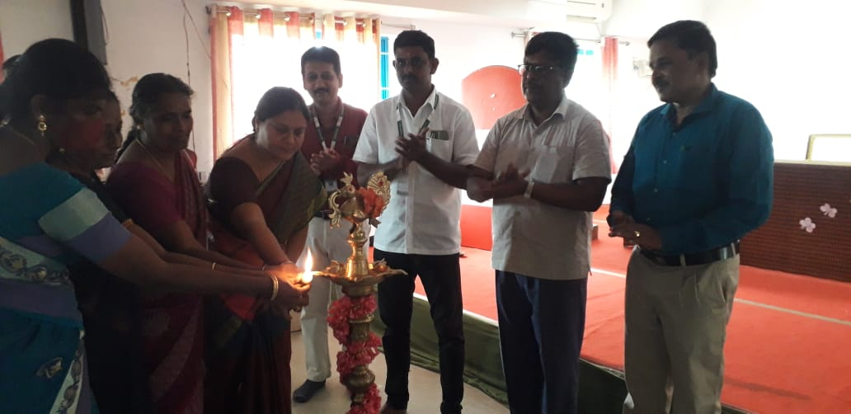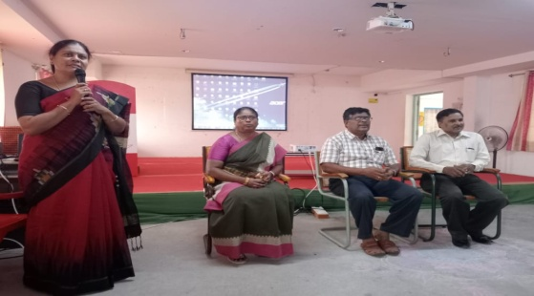

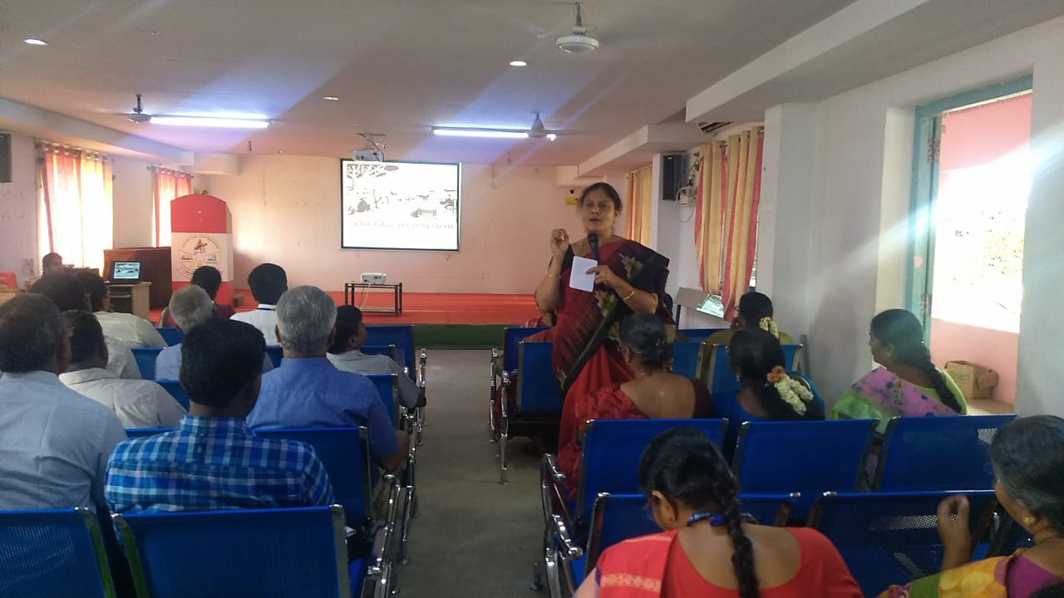
- Co-ordinated Learning Outcome Training for High School HM’s at Padmavani college of Arts and Science on 16-11-2022&17-11-2022. Handled General session on Learning Outcomes.
- Co-ordinated LO Training for Middle school HM’s at Padmavani College of Arts and
- Science on 18-11-2022 &amp; 19-11-2022. Handled General session on Learning Outcomes.
- Attended Faculty meeting regarding integration of content and curriculum preparation work at DIET.
- On 22-11-2022 Carried out The Process In Assessment Cell Related Video- Creation and Curation of Questions at DIET.
- 23-11-2022 and 24-11-2022 –Prepared Plan and executed the work to collect MCQs for class XI,XII BME,BCE via Whatsapp
- Multiple Choice Question preparation for class 6 Math and English on 25-11-2022 was done at DIET.
- Attended Coordination meeting with Azim Premji University faculty member at Pillar Hall, Madurai.
- Conducted Workshop on integration of curriculum and content.
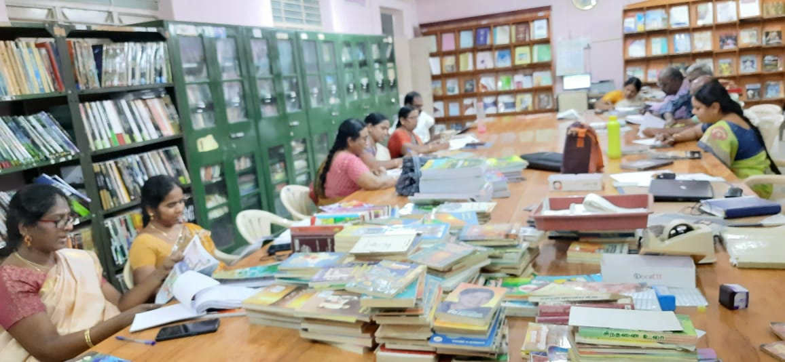
Dr B.Ananthi-Lecturer
1. Attended pre-planning Workshop for the 'Learning Outcomes' Training to be given for CEOs, DEOs (Elementary), DEOs (Secondary), conducted by JD (Training) at SCERT, Chennai on 02/11/22.
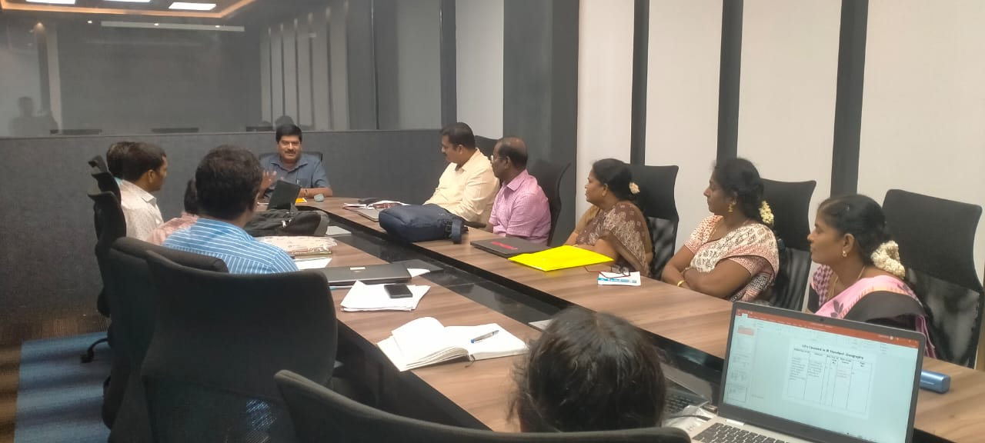
2. Acted as Key Resource Person for 'Learning Outcomes' Training (English) for CEOs at Pillar Hall, Madurai on 05/11/22.
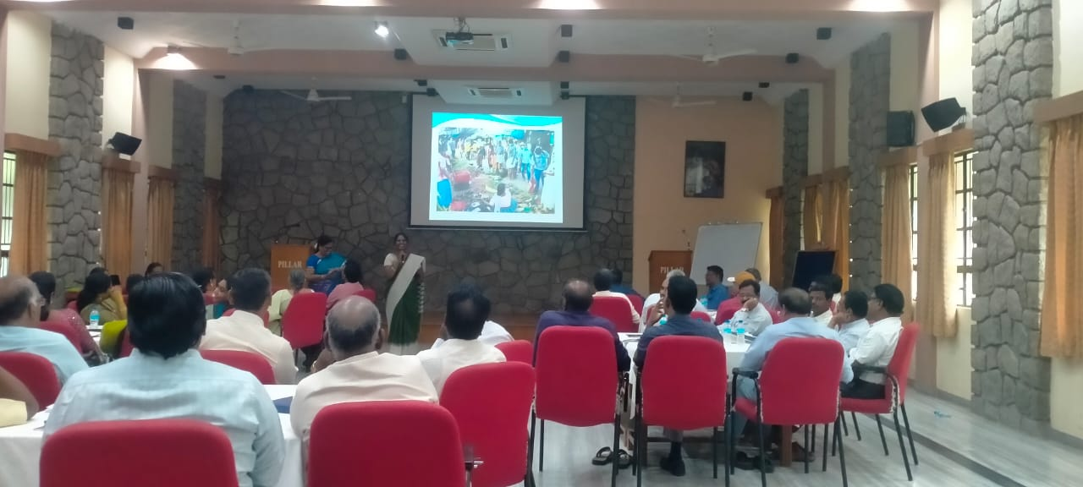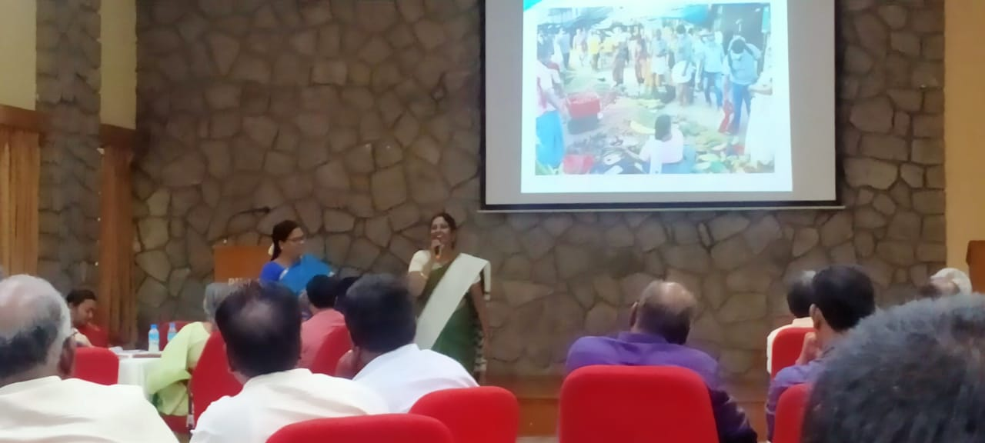
3. Participated in the Co-ordination meeting with DEO (Elementary) and Senior Faculty Mr.Ramnath of Azim Premji Foundation held and DIET, Uthamacholapuram on 09/11/22.
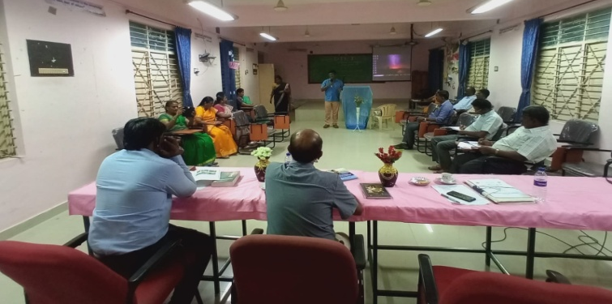
4. Acted as Key Resource Person for 'Learning Outcomes' Training (English) for DEOs (Elementary) at Pillar Hall, Madurai on 12/11/22.
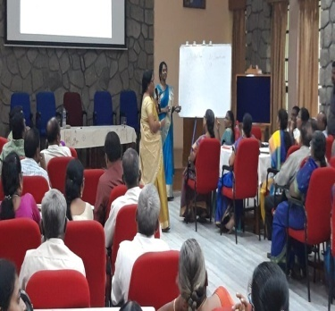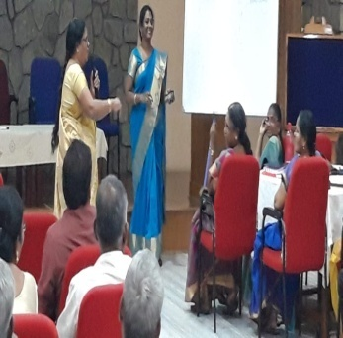
5. Participated and contributed in the Dictionary Proof-reading workshop at AshaNivas, Chennai, conducted by SCERT from 14/11/22 to 18/11/22( 5days)
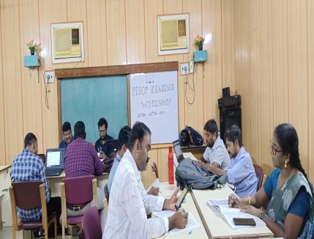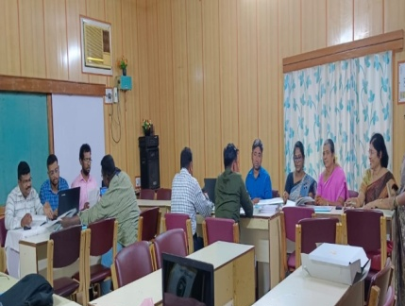
5. Acted as Key Resource Person for 'Learning Outcomes' Training (English) for (Secondary) at Pillar Hall, Madurai on 19/11/22.
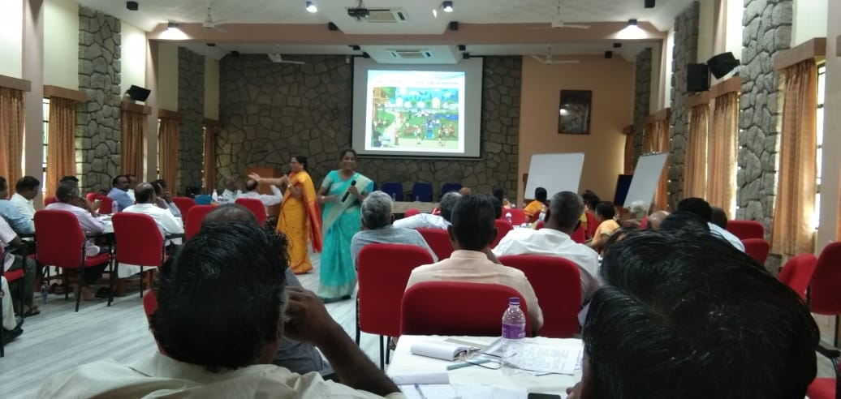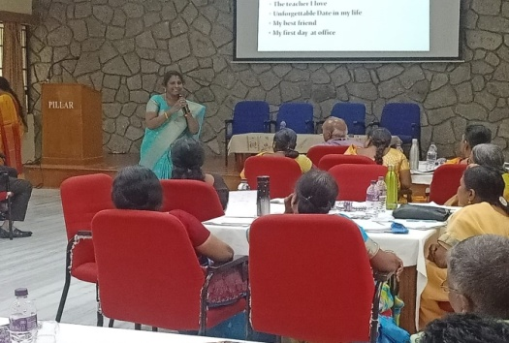
6. Participated and contributed in the Dictionary Proof-reading workshop at AshaNivas, Chennai, conducted by SCERT 28/11/22 to 30/11/22( 5days)
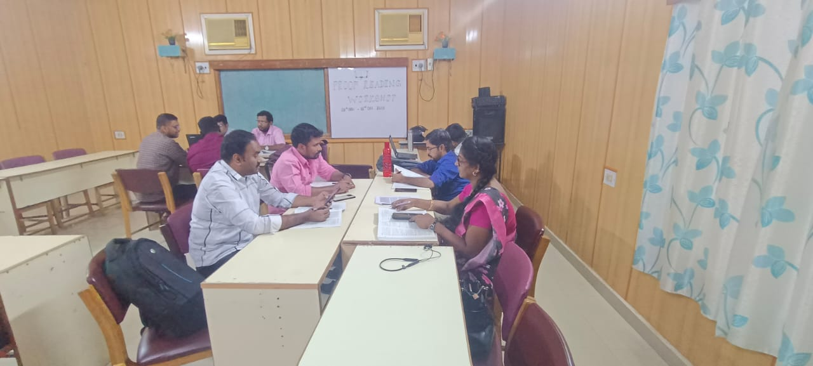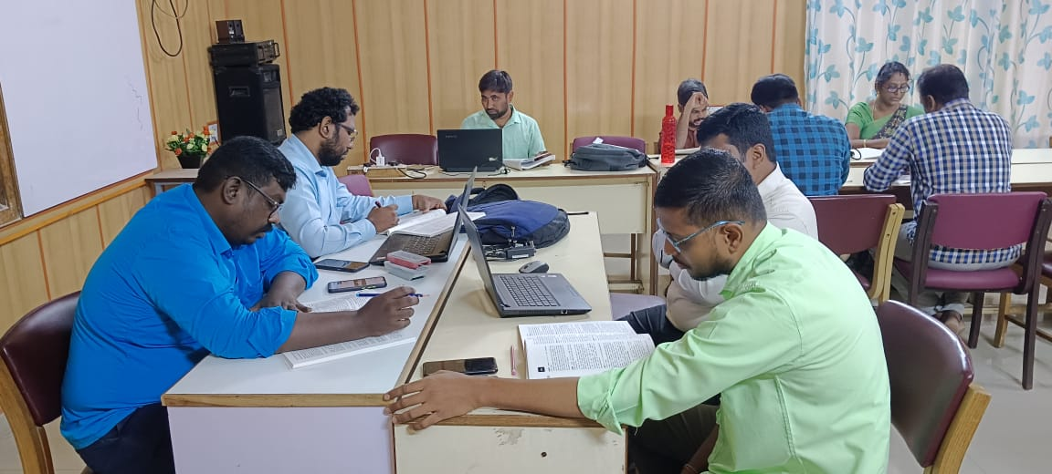
District Resource Unit :(DRU)
Dr T.Prabakaran – Senior Lecturer
- Attended District Facilitator training for CRC on Ennum Ezhuthum on 24.11.2022 and Phonetics on 25.11.2022 at CSI-TTI, Hasthampatty, Salem.
Dr P.SO. Kesavan - Lecturer
- Attended and Participated PSD Training-Essential Themes (2 Phase) at Pillar Training Centre , Madurai from 31.10.22 to 4.11.22
PSD Training-Essential Themes (2 Phase) at Pillar Training Centre, Madurai
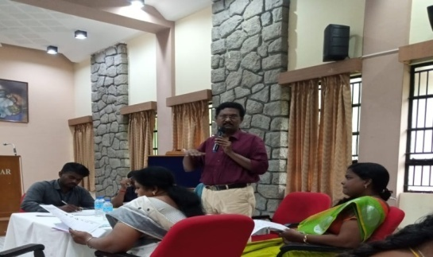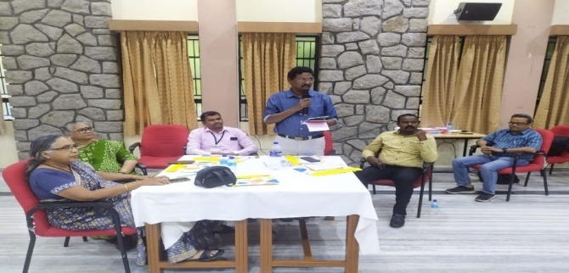
- Attended Faculty meeting regarding Azim Premji University Team visit-pre planning meeting on 7.11.22
- Attended Faculty meeting regarding pre planning for the training to HMs on LOs and prepared power point slides on 8.11.22
- Attended and briefed the work done by DRU branch in the coordination meeting with AzimPremji University Team member on 9.11.22
- School Visit :PUES, Scorates Nagar,Veerapandy Block- Observed Ennum Eluthum class, Assessment , Verified Students’ Work Books, Composition notes and Lesson Plan on15.11.22
- School Visit :PUES, Marulayampalaaayam,Veerapandy Block- Observed Ennum Eluthum class, Assessment , Verified Students’ Work Books, Composition notes and Lesson Plan on 16.11.22
- School Visit:PUMS, Ettimaniyakaranur and PUES, Perumangoundampatty, Veerapandy Block-Observed Ennum Eluthum class, Assessment, Verified Students’ Work Books, Composition notes and Lesson Plan 0n 17.11.22.
School Visit :Ennum Eluthum Class Room Observation
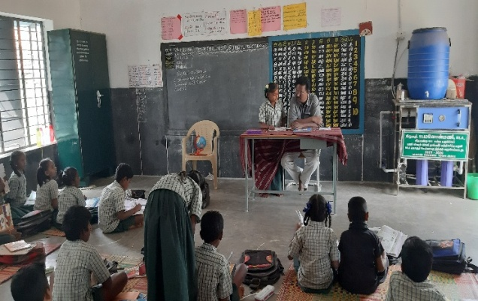 | 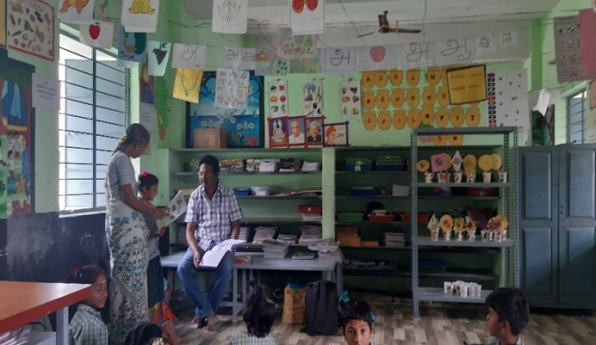
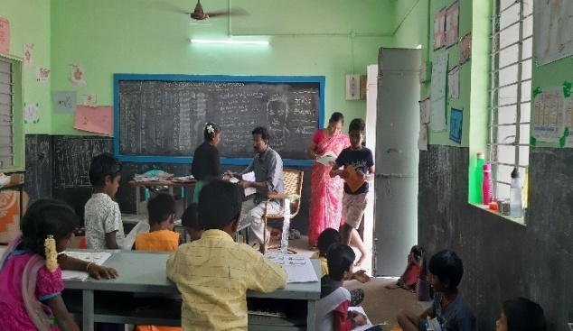 | 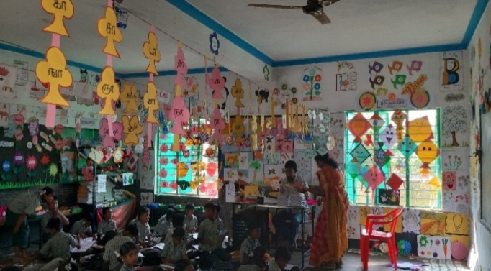
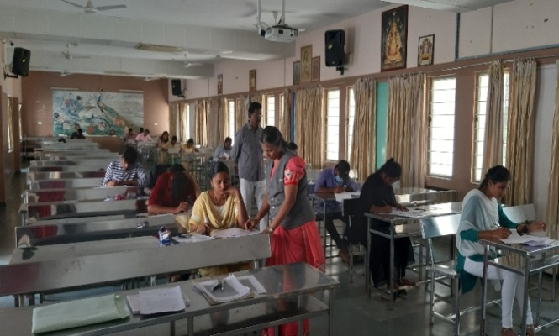
- Acted as OSD for NIOS SEC/ SENIOR SECONDARY examination- at Sri Seshaas Public School, Salem 636 008 0n 21.11.22.
- Visited to Veerapandy and met BEOs and BRTEs-discussed about the Ennum Eluthum programme Classroom observation during school visits on 29.11.22
- Visited Salem Book Fair and participated in “Puthaga Seer” function on 30.11.22

Planning and Management: (P&M)
Dr K.Kannaki-Senior Lecturer
- 14.11.22-Acted as a Resource Person for Learning Outcome Training for Higher Secondary School Heads of Salem District at Padmavani College of Education ,Salem.
- 15.11.22-Acted as a Resource Person for Learning outcome Training for Higher Secondary School Heads of Salem District at Padmavani College of Education ,Salem.
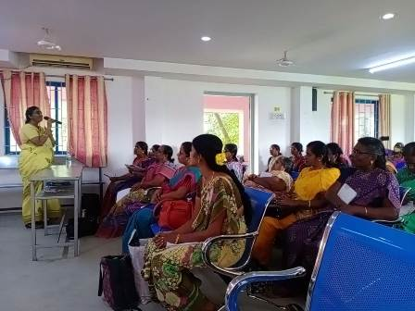
- 16.11.22-Acted as a Resource Person for Learning outcome Training for High School Heads of Salem District at Padmavani College of Education ,Salem.
- 17.11.22-Acted as a Resource Person for Learning outcome Training for High School Heads of Salem District at Padmavani College of Education ,Salem.
- 18.11.22-Acted as a Resource Person for Learning outcome Training for Middle School Heads of Schools at Padmavani College of Education ,Salem.
- Visited Salem Book Fair and participated in “Voluntary Book Donation Programme” to DIET library function at Book Fair on 30.11.22.

Mr. B.Uthayakumar-Lecturer
- 01.11.22 to 03.11.22- Attended Capacity Building Training for DIET faculty Members by Azim Premji University, Bengaluru, Faculty members at Pillar Hall, Madurai.
- 14.11.22-Acted as a Resource Person for Learning Outcome Training for Higher Secondary School Heads of Salem District at Padmavani College of Education ,Salem.
- 15.11.22-Acted as a Resource Person for Learning outcome Training for Higher Secondary School Heads of Salem District at Padmavani College of Education ,Salem.
- 16.11.22-Acted as a Resource Person for Learning outcome Training for High School Heads of Salem District at Padmavani College of Education ,Salem.
- 17.11.22-Acted as a Resource Person for Learning outcome Training for High School Heads of Salem District at Padmavani College of Education ,Salem.
- 18.11.22-Acted as a Resource Person for Learning outcome Training for Middle School Heads of Schools at Padmavani College of Education ,Salem.
- 19.11.22-Acted as a Resource Person for Learning outcome Training for Middle School Heads of Salem District at Padmavani College of Education ,Salem.
Work Experience : (WE)
Dr S.Vijayalakmi Shankar-Senior Lecturer
Date | ACTIVITIES
01.11.2022to  04.11.2022 | Attended CBT -Essential Programme at Pillar Hall, Madurai.
06.11.2022 | Conducted online programme through Google Meet of -AASAN AVAI -47th Special programme - DIET & Rotary MOU -Resource Person : Mr.K.Anandakannan, BT Asst, GHS, Mallaikottalam Kallakuruchi Dt Topic: Basic ICT Resources.
07.11.2022 | Participated in Discussion about CBT programme
08.11.2022 | Attended Principal In -charge-meeting for conducting LO Training to Heads of School Salem District.
09.11.2022 | Attended Principal review meeting on discussion about LO.
13.11.2022 | Conducted online programme through Google Meet-AASAN AVAI - 48th Special programme-DIET & Rotary MOU -Resource Person : Mrs.Sasikala, Psychologist, Helix School, Salem . Topic: Identifying Error Analysis in Mathematics
14.11.2022 | Acted as a Resource Person for Learning Outcome Training for Higher Secondary School Heads of Salem District at Padmavani College of Education, Salem
15.11.2022 | Acted as a Resource Person for Learning outcome Training for Higher Secondary School Heads of Salem District at Padmavani College of Education, Salem
16.11.2022 | Acted as a Resource Person for Learning outcome Training for High School Heads of Salem District at Padmavani College of Education ,Salem
17.11.2022 | 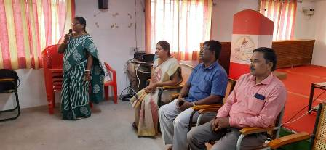  Acted as a Resource Person for Learning outcome Training for High School Heads of Salem District at Padmavani College of Education ,Salem
18.11.2022 | Acted as a Resource Person for Learning outcome Training for Middle School Heads of Schools at Padmavani College of Education ,Salem
19.11.2022 | Acted as a Resource Person for Learning outcome Training for Middle School Heads of Salem District at Padmavani College of Education ,Salem
20.11.2022 | Conducted online programme through Google Meet-AASAN AVAI -49 Special programme – DIET & Rotary MoU – Resource Person : Dr K.RameshKumar, Lecturer, DIET, Uthamacholapuram, Salem-10 Topic: Enriching Professional Development in ICT.
21.11.2022 | Attended Principal Review Meeting-Discussed about LO Training and Prepare additional life oriented activities for VI Standard Science subject.
22.11.2022-25.11.2022 | Preparation of additional life- oriented activities for VI Standard Science was done.
28.11.2022 | Collected Reference materials from Teachers Plus Magazine for School Activities programme.
29.11.2022 | Visited schools to find the impact study of BAMBOOZLE & SCATCH Gamification tool visit to along with Principal 1.PUES,T.Konagappadi 2.PUMS,K.Pudur3.PUMS,Nachampatti.
30.11.2022 | Attended Principal review meeting and discussed about “Voluntary Donation of Books to DIET Library”.  Visited as a part exposure visit to Salem District Book Fair(Puthaka Thiruvizha- Salem)

Mr. C.Anbarasan-Lecturer
- 14.11.22 to 16.11.22- Coordinated and Acted as resource person for “NaanMudalvan” training programme at Padmavani College, Salem.
- Attended District Facilitator training for CRC on Ennum Ezhuthum on 24.11.2022 and Phonetics on 25.11.2022 at CSI-TTI, Hasthampatty, Salem.
- Attended Coordination meeting by Mr.Ramnath, Azim Premji University, Bengaluru and Mr.Santhosh, DEO (Elementary)Salem.
- Visited Salem Book Fair and participated in “Voluntary Book Donation Programme” to DIET library function at Book Fair on 30.11.22.

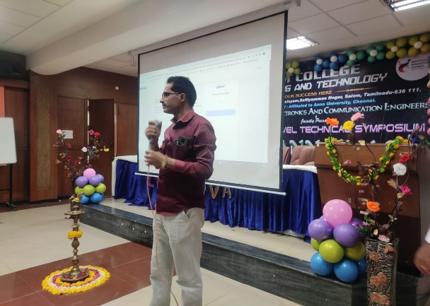
Dr K.Kalaivanan-Lecturer
- 14.11.22 to 16.11.22- Coordinated and acted as Resource Person for “Naan Mudalvan” training programme Salem Engineering College, Mettupatty, Salem.
- Attended District Facilitator training for CRC on Ennum Ezhuthum on 24.11.2022 and Phonetics on 25.11.2022 at CSI-TTI, Hasthampatty, Salem.
- Attended Discussion meeting on DIET initiatives and activities with Mr.Ramnath, Azim Premji University, Bengaluru and Mr.Santhosh, DEO (Elementary)Salem.
- Visited Salem Book Fair and participated in “Puthaga Seer” function on 30.11.22.
- Visited Salem Book Fair and participated in “Voluntary Book Donation Programme” to DIET library function at Book Fair on 30.11.22.

Mr. K.Satchidanandam - Librarian
- 09.11.2022-Attended Discussion meeting with Mr.Ramnath, AzimPremji University, Bengaluru and Mr.Santhosh, DEO (Elementary) and explained about DIET library activities and programmes.
- 14.12.2022-Visited Learning Outcome training centre along with DIET, Principal at Padmavani College, Salem.
- 30.12.2022- Organized and Coordinated voluntary book donation programme to DIET library from Salem Book Fair and received about more than 150 books from generous donors.
Chief Editor : Dr M.SELVAM, Principal Uthamacholapuram, Salem-636 010
Edited and Published by : Publication Division DIET, Salem.
Phone : 7373003460
Website : www.dietsalem.com
Mail Id : dietslm@gmail.com


